Restrictive Practices System

Guide: Provider Registration

Contents
1 Introduction 3
1.1 About this guide 3
1.2 Introduction to the Restrictive Practices System 3
1.3 Icons used in this guide 3
1.4 Glossary of Terms 4
2 Creating your provider account 5
2.1 Access the Restrictive Practices System 5
3 Completing your provider registration 6
3.1 Add provider information 6
3.2 Add NDIS registration 8
3.3 Add key personnel information 10
3.4 Submit the provider registration application 11
4 Accessing the Restrictive Practices System 13
4.1 Access and follow instructions in the Registration Email 13
5 RPS Home Dashboard 16
6 Updating your provider details 17
6.1 Updating your provider profile 17
6.2 Updating NDIS Registration details 19
6.3 Updating Key Personnel 20
6.4 Adding and Updating Outlet Information 21
7 Logging Out 23
7.1 Logging out of the Restrictive Practices System 23

Introduction

About this guide
This guide helps registered NDIS providers to find, add and edit a participant within the South Australian Restrictive Practices System.

Introduction to the Restrictive Practices System
The Restrictive Practices System (RPS) is the online system for managing the application, authorisation, and reporting of restrictive practices by NDIS service providers for NDIS participants in South Australia.
This guide provides information about:
- how to search for a participant within the RPS
- how to add participants who are not yet recorded within the RPS
- how to edit participant information within the RPS.
Note: Instructions for registering a provider account and adding a participant are excluded from this training guide. Refer to the following guides for further information:
<Guide – Provider Registration>
<Guide- Finding, Adding and Editing a Participant>

Icons used in this guide
Throughout this guide you will find icons representing various kinds of information to help you follow the guide effectively.

Icon | Description
 | Information – provides context for the following process steps
 | Note – contains important information to be aware of
 | Stop – before proceeding with the next step, there may be information you need to have available, or there may be something you need to do or check

Glossary of Terms

Term | Definition
Restrictive Practices System (RPS) | The online system for managing the application, authorisation and reporting of restrictive practices by NDIS providers providing NDIS supports to NDIS participants in SA.
CEO or equivalent | This is the Senior Executive / Manager responsible for the operations of the NDIS service provider in South Australia. For some providers, this will be a Chief Executive. For other (especially national organisations with a South Australian presence), this may be the SA state manager.
Account Owner | The Account Owner is the systems administrator for NDIS service provider who can nominate the Authorised Program Officers for their provider.
Authorised Program Officers (APO) | This is a key role in the South Australian Restrictive Practices authorisation scheme. APOs can authorise Level 1 restrictive practices by their registered NDIS provider for NDIS participants and may endorse the use of Level 2 restrictive practices for the Senior Authorising Officer’s authorisation.
Senior Authorising Officer (SAO) | The Senior Authorising Officer has statutory responsibilities to:  - Approve appropriate persons to be Authorised Program Officers  - Approve restrictive practices, including Level 2 practices  - Provide education, training and support to reduce and eliminate the use of restrictive practices where possible
Restrictive Practices Team | Also known as the Restrictive Practices Unit and the Restrictive Practices Authorisation Team. The team supports the SAO to undertake their statutory functions and provides support to NDIS providers using the Restrictive Practices System. The team can be contacted at:  DHSRestrictivePracticesUnit@sa.gov.au

Creating your provider account

Access the Restrictive Practices System
Step | Action
1 | Go to https://www.rps.sa.gov.au/login and click Create Your Provider Account.  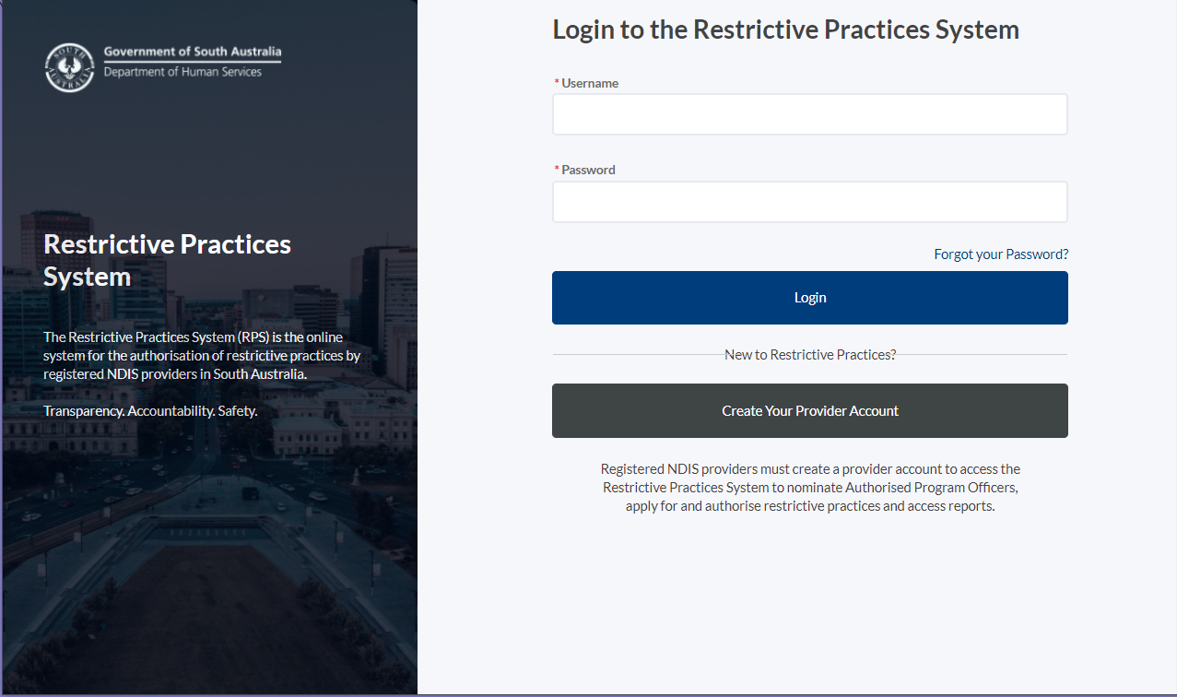
The Provider Registration screens will be displayed. The following section of this guide will take you through the provider registration process.
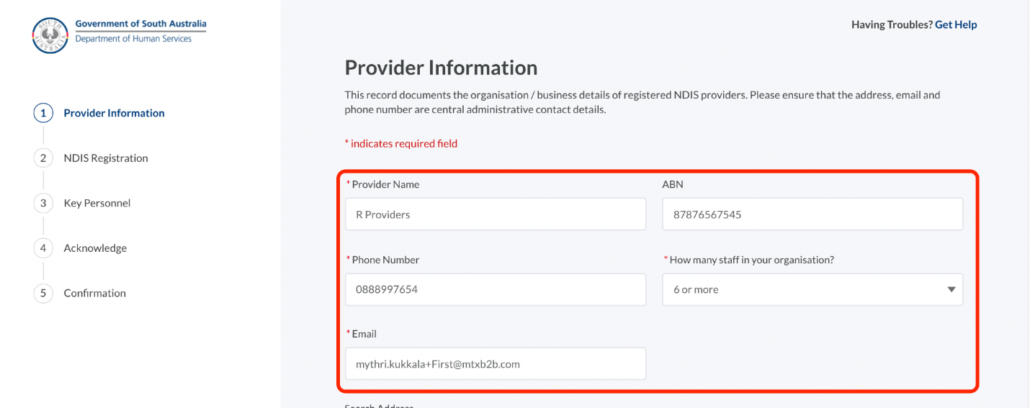

Completing your provider registration

Add provider information
Step | Action
The Restrictive Practices System will guide you through the provider registration process via the following steps:
- Provider Information
- NDIS Registration
- Key Personnel
- Acknowledge
- Confirmation
The registration process enables you to complete each step sequentially.
Before you get started, please ensure you have everything you need to complete the registration screens. You will need:
- Your Chief Executive (or equivalent’s) authority to register your organisation on the Restrictive Practices System.
- Your Chief Executive (or equivalent’s) authority to be the Account Owner. The Account Owner is generally a senior member of staff, e.g. Officer Manager, Team Leader, Manager or similar. This person will have the authority to register the provider, nominate the APO (on behalf of the CEO), add/edit any other users to the system and access data reports.
You will also need the following details:
- The Chief Executive Officer (or equivalent’s) name, phone number and direct email address.
- The details you want to use as the Account Owner (direct phone number and email address).
- ABN (Australian Business Number)
- NDIS registration details (and documentation if available)
- The NDIS Registration Group(s) (“Class of Supports”) your organisation currently delivers.
The Provider Registration process cannot be saved during the data entry process. If you select Cancel this will exit the process and you will need to start again.
All mandatory fields marked with * must be entered to enable progression between registration screens.
1 | Enter your Provider Details:  - Provider Name  - ABN  - Phone Number – this should be a generic number that is publicly available for your organisation.  - How many staff in your organisation – this information helps the Restrictive Practices Team know if you may need additional support with authorisations  - Email – this should be a generic email that is publicly available and not likely to change with staff movements.
2 | Enter the full address in the Address field. As you type, possible matches will be presented. Select the correct address from the list.  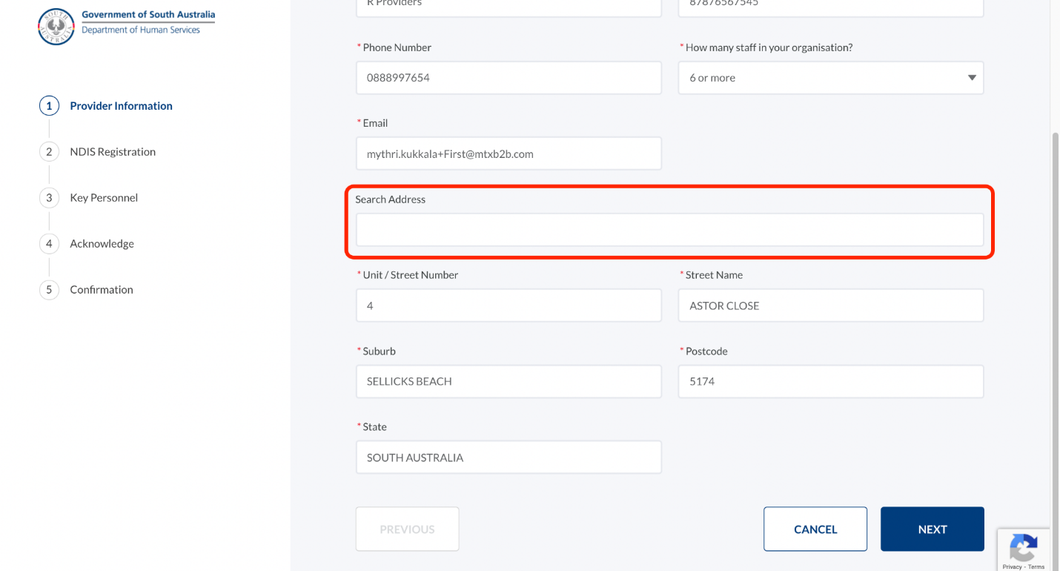
 | The selected address populates in the respective fields. If you cannot find your organisation’s address or the address does not auto-populate, you can manually enter or edit the address if required.
3 | Click Next to access NDIS Registration screen.

Add NDIS registration
Step | Action
The NDIS Registration screen captures details about your organisation’s registration with the NDIS Quality and Safeguards Commission.
Providing NDIS registration documentation is not mandatory, however, it assists the Restrictive Practices Team reviewing the application. The type of document that can be upload may include:
- Registration documentation provided by the NDIS Commission
- Audit certification documents (particularly for Module 2a)
1 | Enter the following details related to registration:  - NDIS Provider Registration Number  - Registration Expiry Date  - Registration Groups  You can select multiple registration groups by clicking the group and the > arrow for each applicable group. Groups added in error can be de-selected via the < arrow.  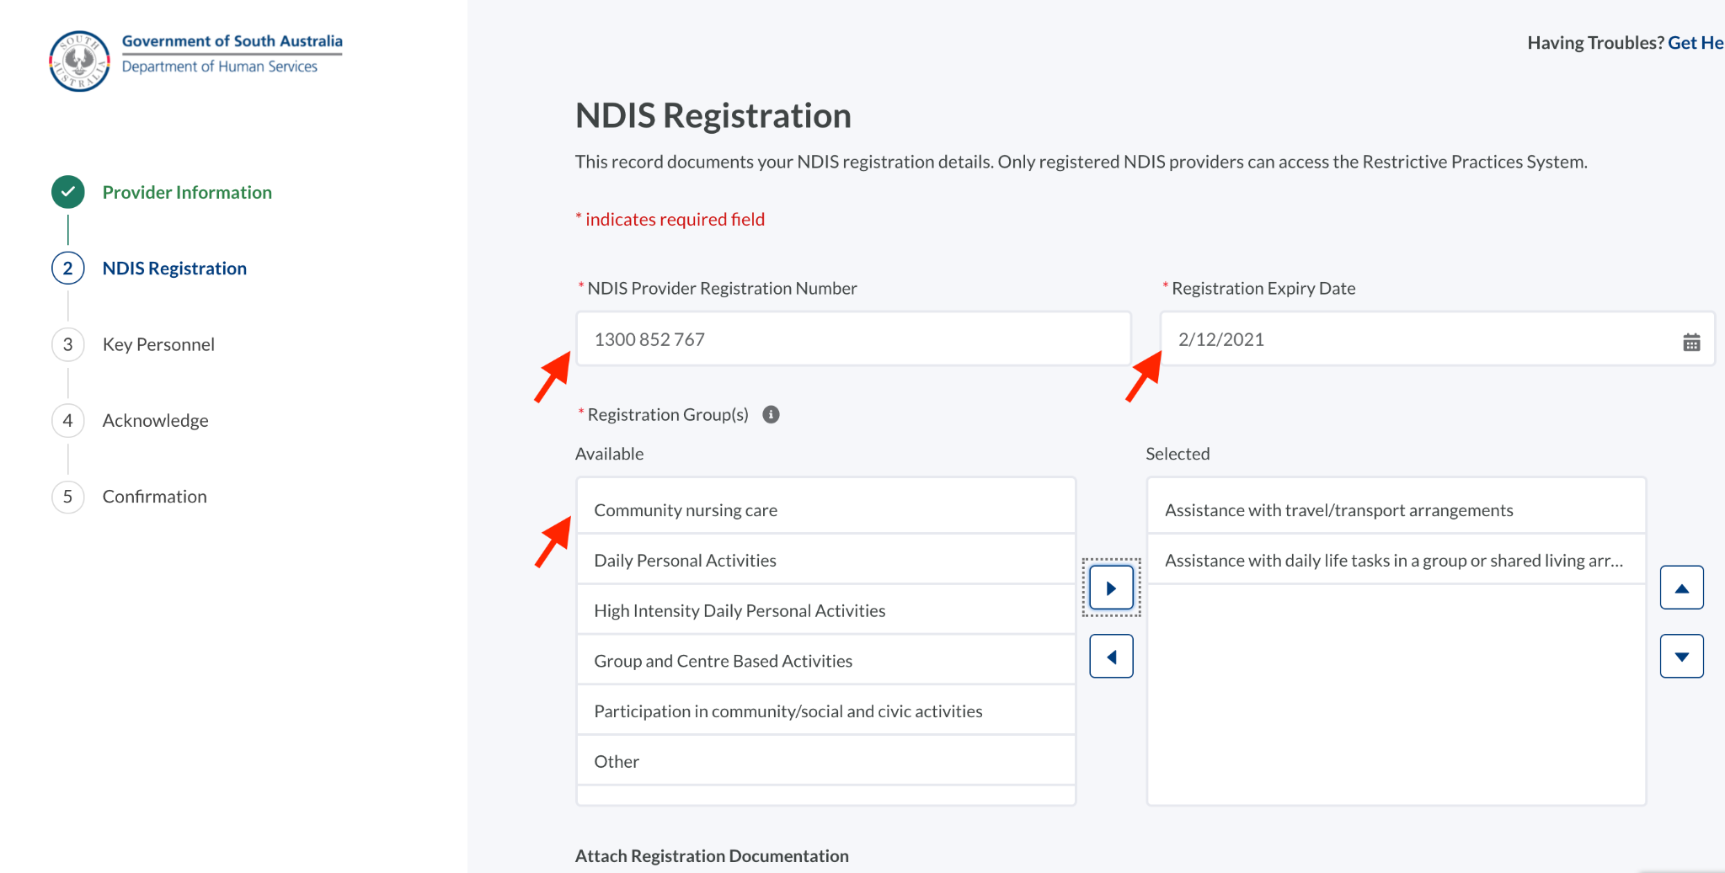
2 | Upload documents related to the NDIS registration if available.  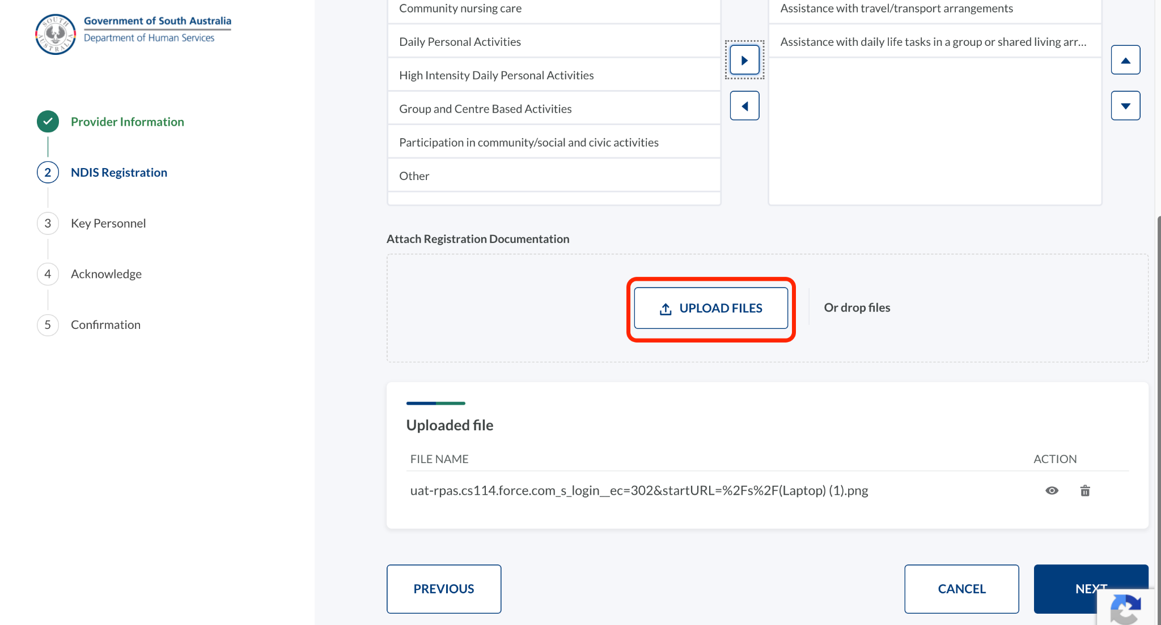
3 | Click Next to access Key Personnel screen.

Add key personnel information

Step | Action
 | The Key Personnel screen captures details of the Chief Executive and Account Owner details. Refer to the information in Section 3.1 Add provider information for descriptions for each role.
1 | Enter the details of the Chief Executive (or the equivalent) and Account Owner Details.  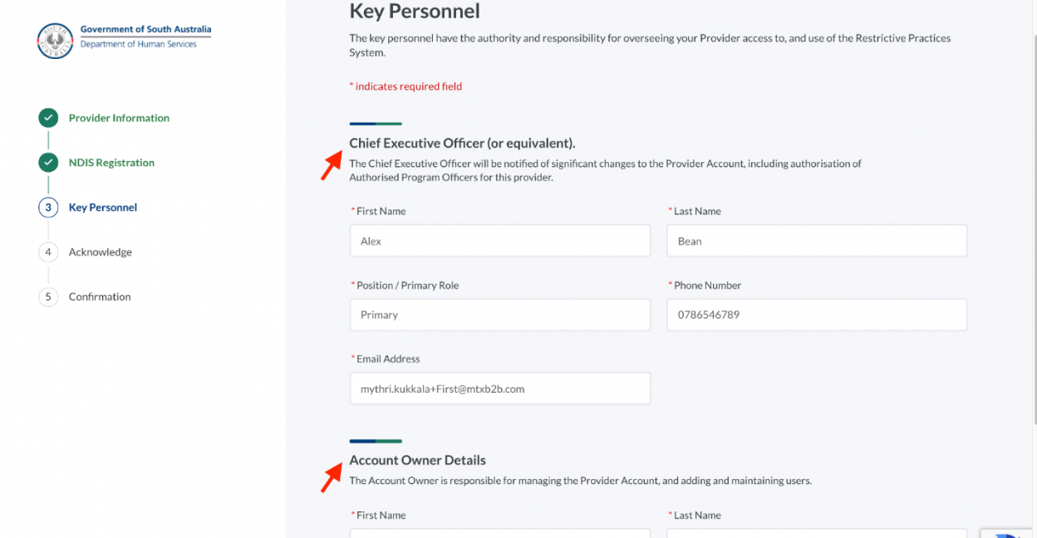
2 | Click Next to access the Acknowledge screen.

Submit the provider registration application

Step | Action
 | To submit the application, the Acknowledge and Confirmation screens must be completed.
1 | On the Acknowledge screen, read the terms, tick the check-boxes and click Submit.  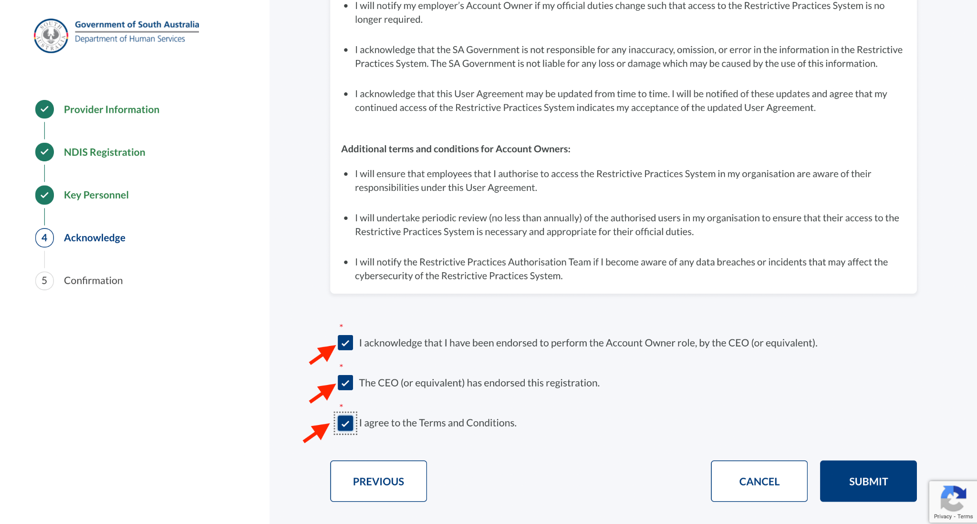
2 | At the prompt, click Yes to submit the application.  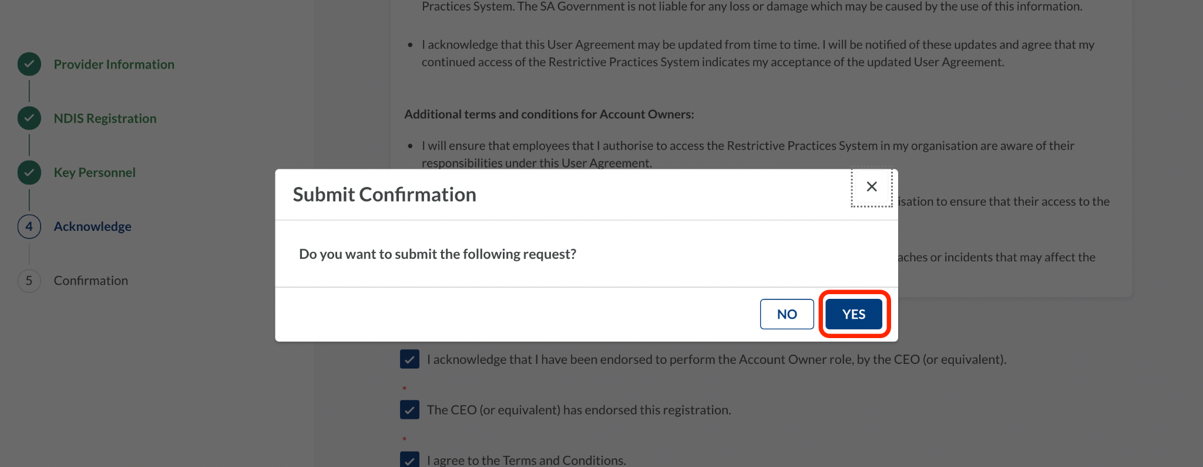
The Confirmation screen will be displayed.
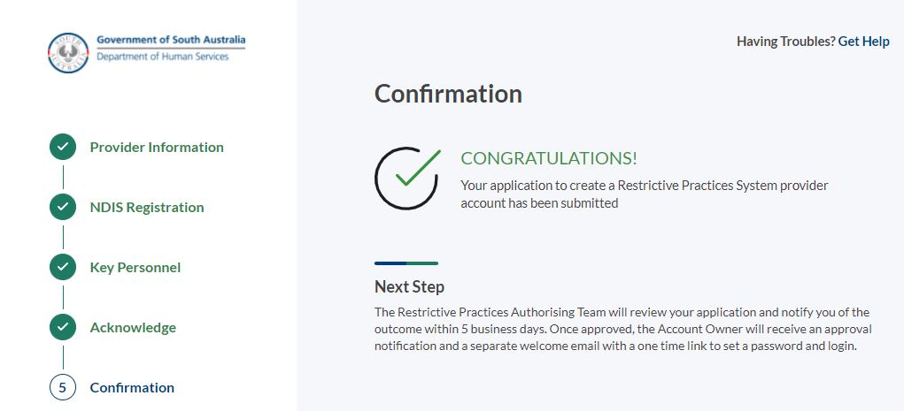
The Restrictive Practices Team will review your application and notify you of the outcome within 5 business days.
If your application has been approved, you will receive the following emails:
- An approval notification to the Chief Executive (or equivalent)
- An approval notification to the Account Owner
- A welcome email with the login details to the Account Owner
If the application is not approved, you will be notified, and a Restrictive Practices Team member will contact you to discuss your application further.

Accessing the Restrictive Practices System

Access and follow instructions in the Registration Email

Step | Action
To access the Restrictive Practices System, you will need to open the welcome email from the Restrictive Practices Team. This enables you to:
- Verify your account
- Set your password
- Save the link to the Restrictive Practices System for future access.
1 | Open the email you have received from the Restrictive Practices Authorisation Team.
 | If the email is not in your inbox, check your spam / junk mail folders in case your login credentials have been directed there.
2 | Click the link available under Verify.  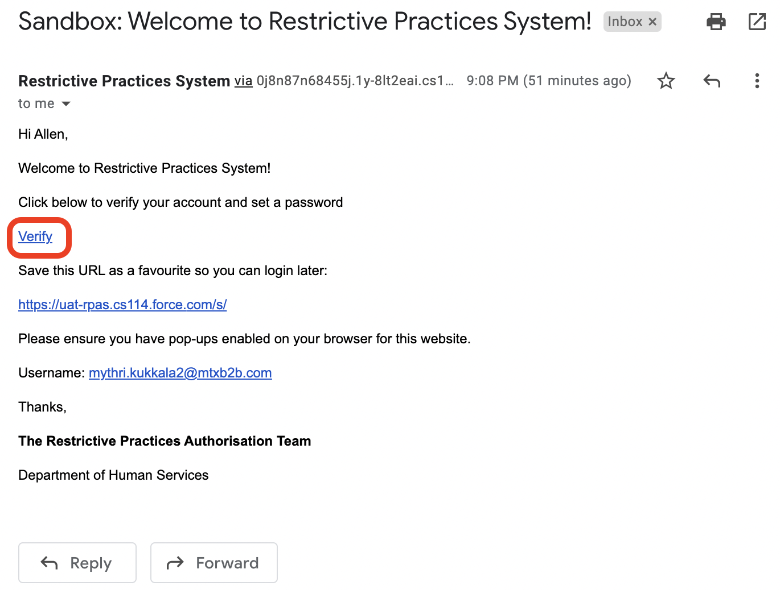
The “Connect Salesforce Authenticator” screen will be displayed.
As part of the verification process you will need to complete a multi-factor authentication (MFA) process. This is to provide additional security for your login credentials and requires access to an authentication application on your mobile phone.
3 | Read the instructions on the Connect Salesforce Authenticator screen, and either:  - Follow the on-screen instructions for the Salesforce Authenticator OR  - Select Choose Another Verification Method. This will provide you with an option to scan a QR code and use verification codes from a different authenticator application, such as the Microsoft or Google Authenticator applications.  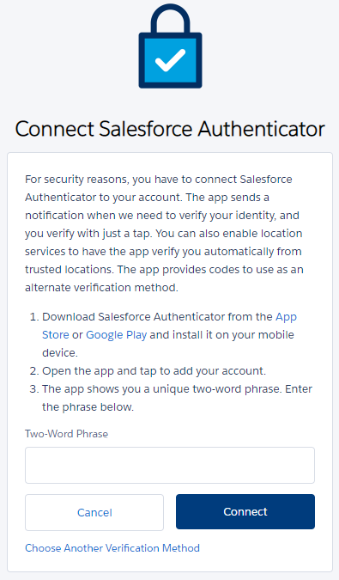
4 | Follow the instructions provided on screen and via your chosen multi-factor authenticator application.
 | Once your multi-factor authentication has been set up, you will be presented with the Change Your Password screen.
5 | Enter your password in the New Password and Confirm New Password fields, then click Change Password.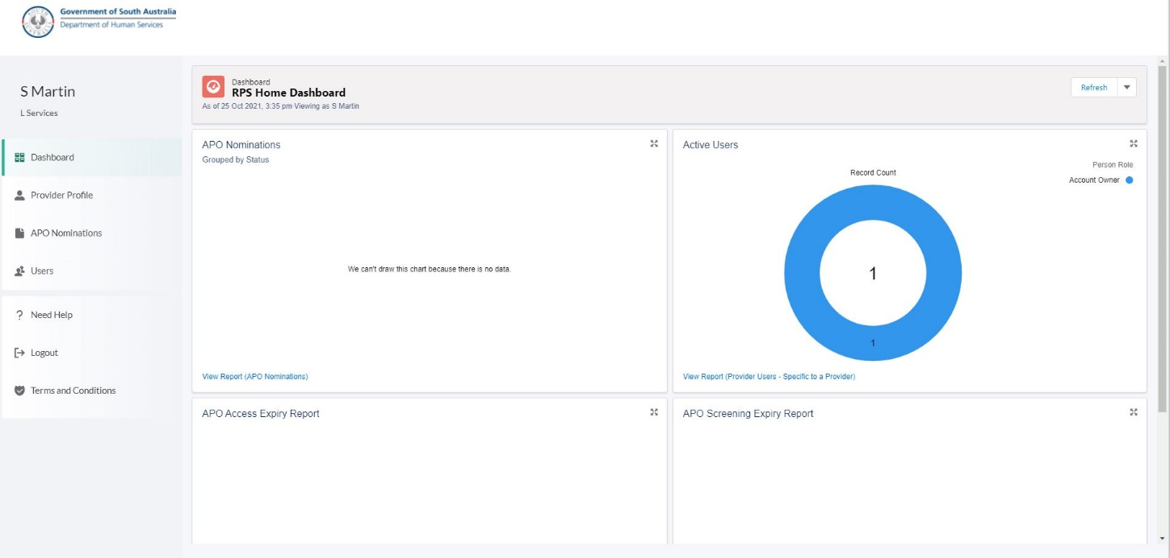  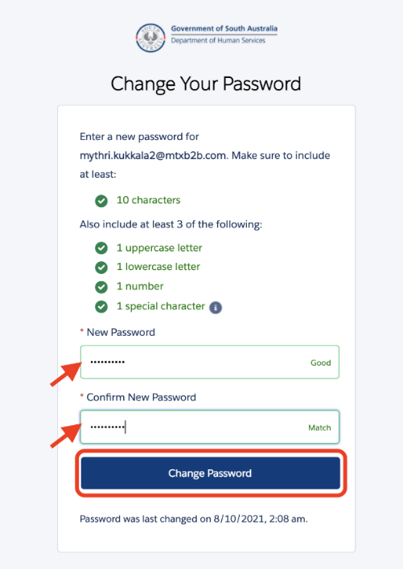
6 | Read the Terms & Conditions and click Agree to give your consent.  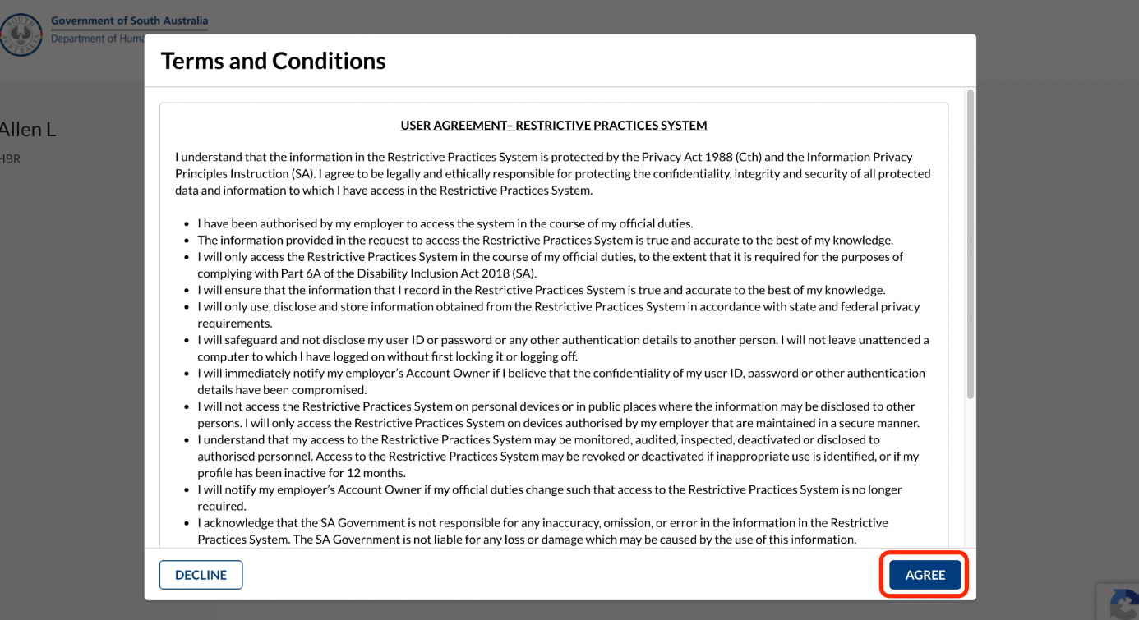
 | Once you have agreed to the User Agreement, you will be logged into the Restrictive Practices System.
7 | Save the link to the Restrictive Practices System as a Favourite, either from your browser, or via the URL in the welcome email if not already saved.
 | In future, you will be able to login to the Restrictive Practices System via the Login button on the home screen.

RPS Home Dashboard
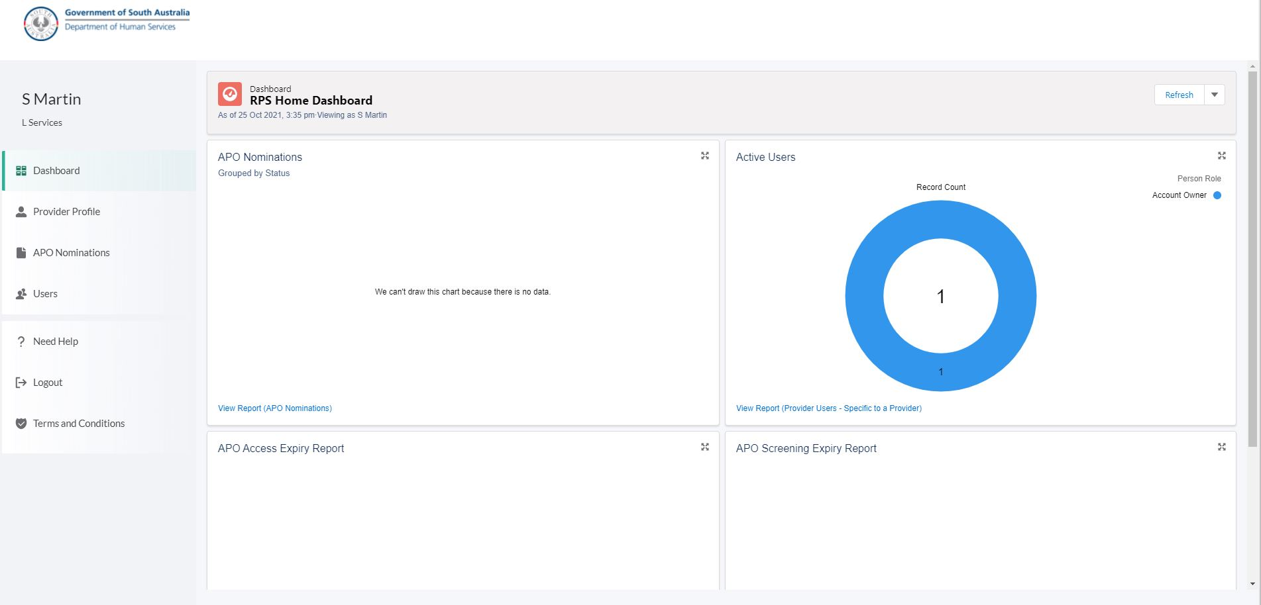

Menu Item | Function
Dashboard | Provides an overview of APO Nominations and Active Users of the Restrictive Practices System. Note: Additional functionality will become available in a future release.
Provider Profile | Provides view / edit details for your Provider Information, NDIS Registration, Key Personnel and Outlet Information.
APO Nominations | Provides the ability to nominate new APO nominations and view any nominations pending authorisation. Note: Once an APO has been authorised, they will appear in the Users list.
Users | Provides the ability to view and edit existing users and add new users.
? Need Help | Provides contact details for the Restrictive Practices Team.
Logout | Logout button.
Terms and Conditions | Displays the Terms and Conditions (User Agreement) for the Restrictive Practices System.
Refresh | The Refresh button is located at the top right of the Dashboard. Click on the button to refresh the screen with any updated information.

Updating your provider details

Updating your provider profile

Step | Action
The Restrictive Practices System enables you to update your provider information. Depending on the tab selected, you can update:
- Provider information
- NDIS registration details
- Outlet information.
1 | Click the Provider Profile available on the left side of the application.  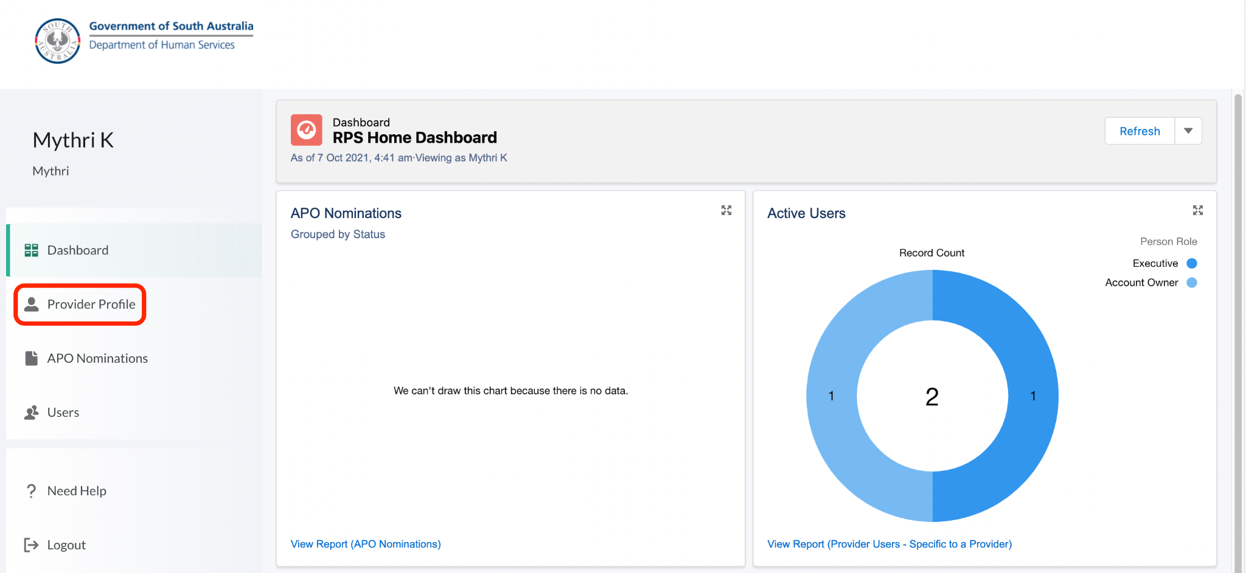
2 | To edit the Provider Information, click Edit.  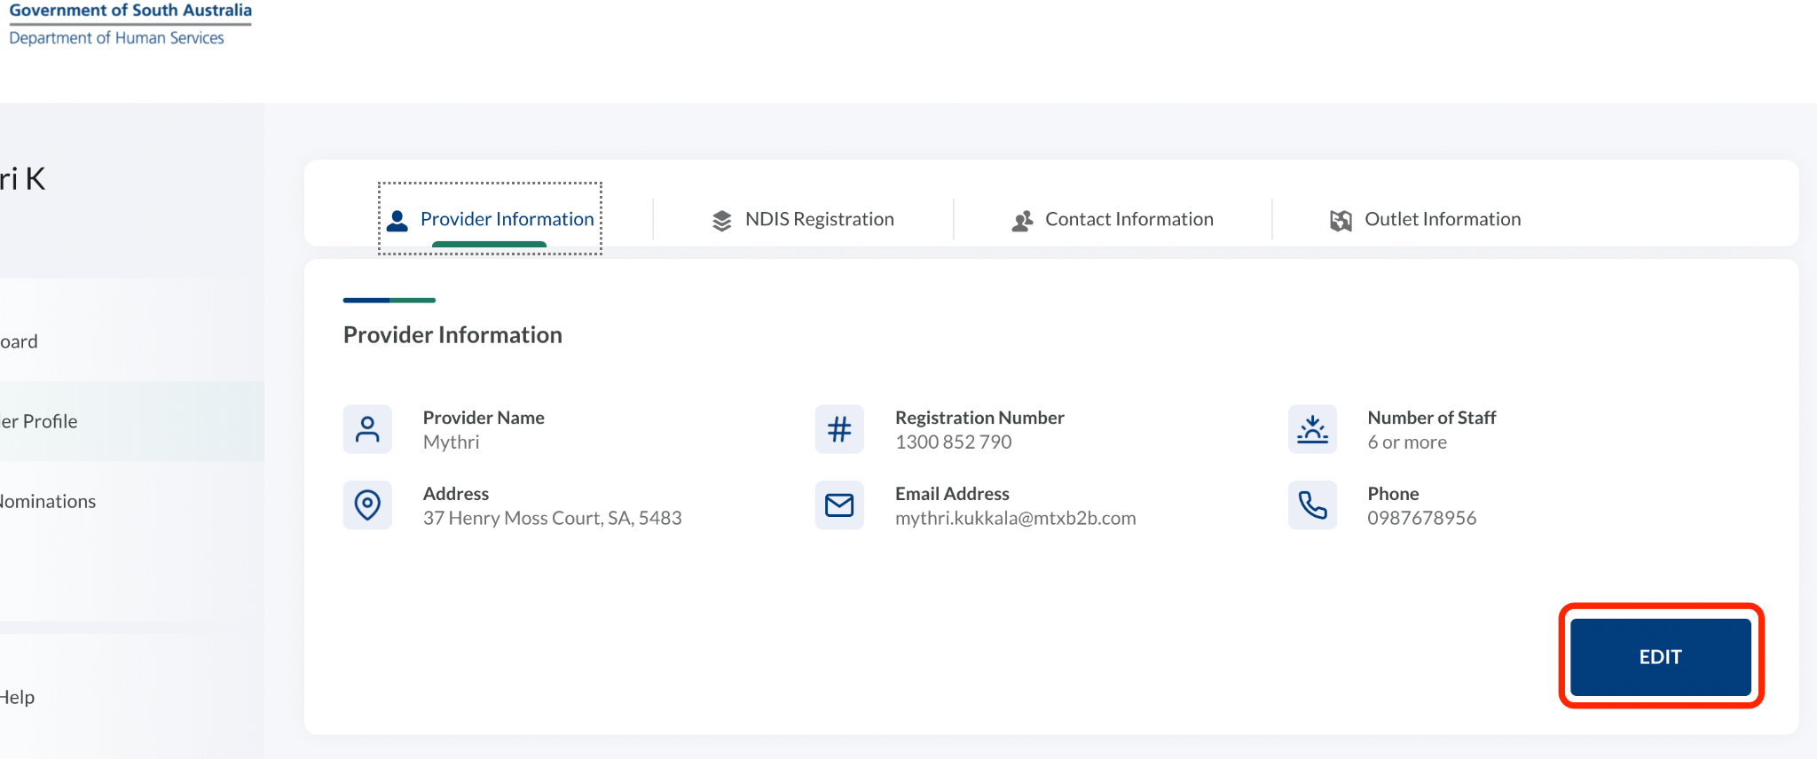
3 | Update the necessary information and click Update.  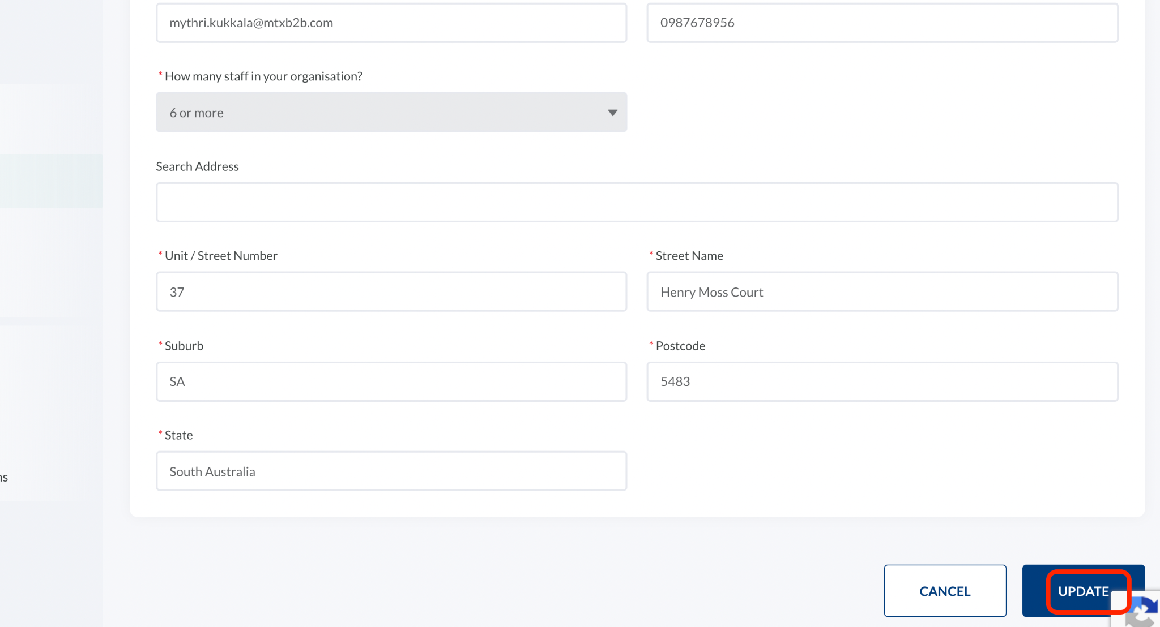
 | The Provider Information will be updated.
 | Not every field is available for update. Please contact the Restrictive Practices Team if you make corrections to the view only fields.

Updating NDIS Registration details

Step | Action
 | The Restrictive Practices System enables you to update your NDIS registration details.
1 | Click the Provider Profile available on the left side of the application, then click the NDIS Registration tab.
2 | To edit the NDIS Registration details, click Edit.  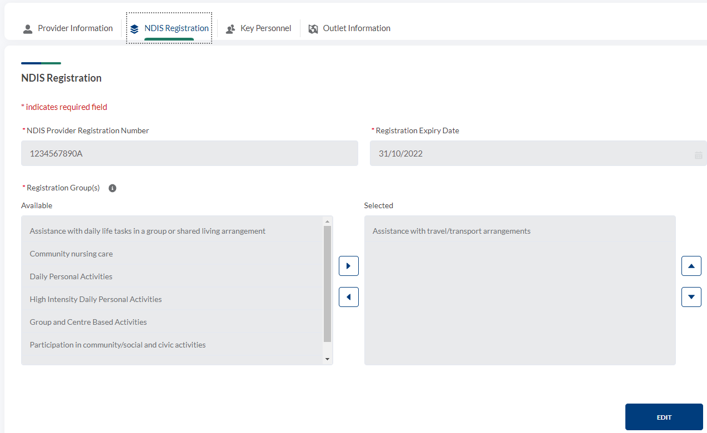
3 | Update the necessary information and click Update.  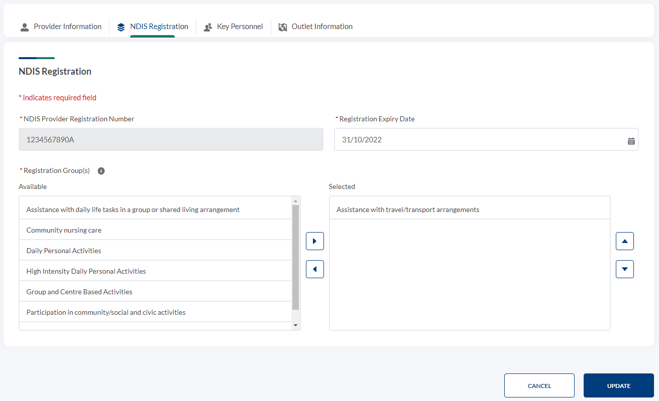
 | The NDIS registration details will be updated.
 | Not every field is available for update. Please contact the Restrictive Practices Team if you need to make corrections to the view only fields.

Updating Key Personnel

Step | Action
 | Please contact the Restrictive Practices Team if you need to make corrections to Key Personnel.

Adding and Updating Outlet Information

Step | Action
 | The Outlet Information screen enables you to add additional outlets, i.e. a branch of your organisation located at a different suburb or region.
1 | Click the Provider Profile available on the left side of the application.
2 | Click the Outlet Information tab.  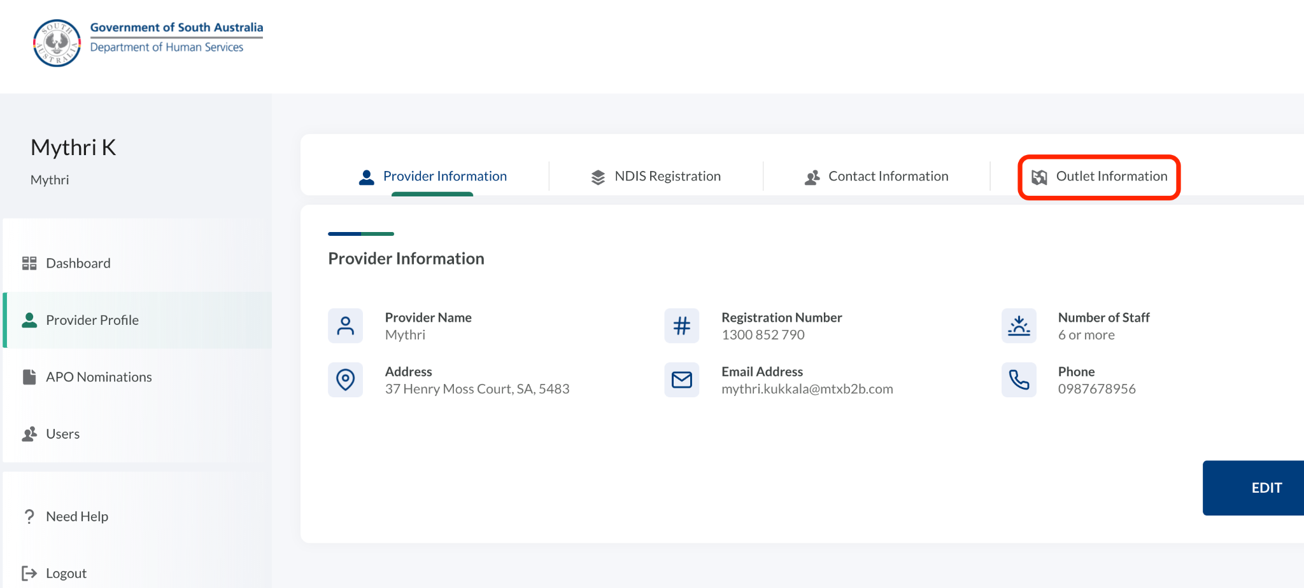
3 | Click Add New.  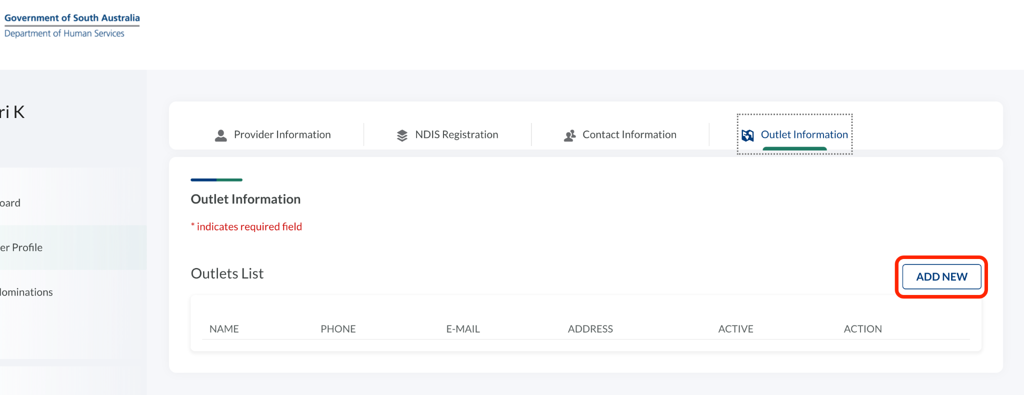
4 | Enter all the necessary details and click Save.  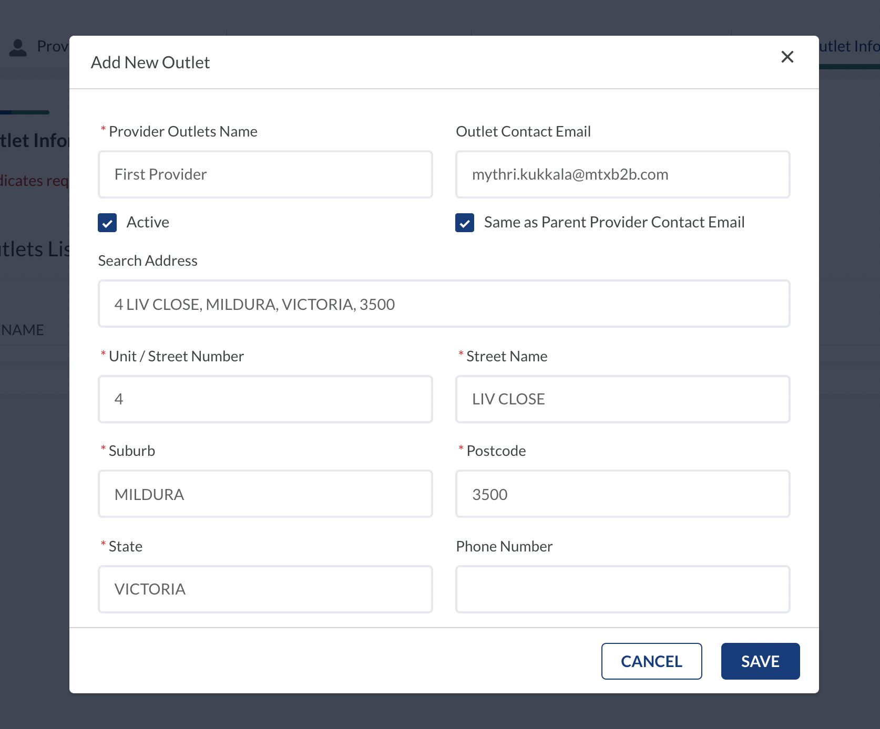
 | The Outlet has been added to your provider details.
5 | Repeat steps 3 and 4 to add additional outlets.

Logging Out

Logging out of the Restrictive Practices System

Step | Action
 | The Restrictive Practices Team recommends you logout of the Restrictive Practices System when not in use. This is especially important if you share computers within your office as it prevents unauthorised use of the system.
1 | Navigate to the Logout option on the left side of the application.  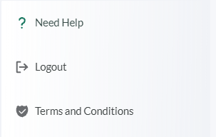
2 | Click Logout.
 | You are now logged out of the Restrictive Practices System.

